Faculty Multiethnic Statistics

The following data was collected from the American Medical Association (AMA) and the American Association of Medical Colleges (AAMC). AAMC data collected via Faculty Roster Systems (utilizing 111 [in 1981] and 112 [in 2001] schools) and AMA via national survey. The AAMC data does not distinguish between mainland Puerto Rican and Commonwealth Puerto Rican. Underrepresented minorities in AAMC data are defined as African American, Mexican American, Puerto Ricans and Native Americans. These data are the most recent figures on the subject, comprising data collected from 1981 to 2001, reported in 2002 in JAMA and the AAMC.
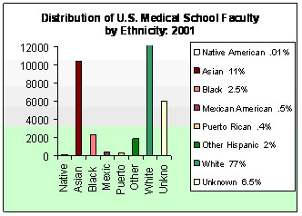
Distribution of US Medical School Faculty by Race/Ethnicity
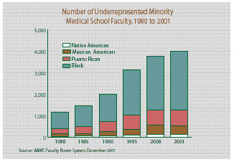
Number of Underrepresented Minority Medical School Faculty
- Numbers of underrepresented minority faculty increased 250% within twenty years, while full-time medical school faculty increased 110%.
- Even with doubling in the numbers, underrepresented minority faculty still account for only 4.2% of US medical school faculty.
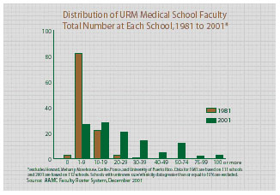
Distribution of Underrepresented Minority Medical School Faculty - Total Number at Each School, 1981 to 2001
- Although numbers of underrepresented minority faculty at non-minority medical schools have more than tripled, few non-minority schools have what might be termed a "critical mass" of underrepresented minority faculty.
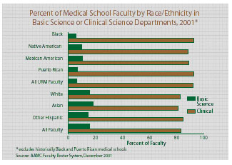
Percent of Medical School Faculty by Race/Ethnicity in Basic Science or Clinical Science Departments, 2001
- The majority of underrepresented minority faculty work in clinical departments. Less than 7% of these faculty hold appointments in basic science departments. Almost 16% of all faculty hold appointments in basic-science departments.
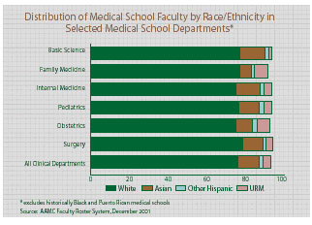
Distribution of Medical School Faculty by Race/Ethnicity in Selected Medical School Departments
- Underrepresented minority faculty are more likely to hold appointments in family medicine or obstetrics & gynecology. They are least likely to hold appointments in a basic science department.
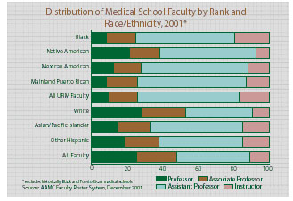
Distribution of Medical School Faculty by Rank and Race/Ethnicity, 2001
- Less than 10% of underrepresented minority faculty, at non-minority medical schools, are full professors.
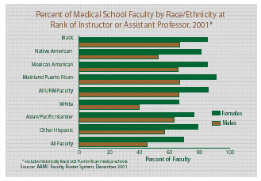
Percent of Medical School Faculty by Race/Ethnicity at Rank of Instructor or Assistant Professor, 2001
- Women, regardless of race or ethnicity, are more likely to hold faculty ranks of Instructor or Assistant Professor. More than 80% of all underrepresented minority women faculty in non-minority medical schools are Instructors or Assistant Professors.
University of Cincinnati College of Medicine Faculty Statistics
UCCOM Full and Part-time Faculty:
- 1,286 Total faculty
  - Caucasian - 1,064 (83%)
  - Asian, including Pacific Islander - 168 (13%)
  - African American - 28 (2.1%)
  - Hispanic - 23 (1.7%)
  - Native American/Alaskan Native - 3 (0.2%)
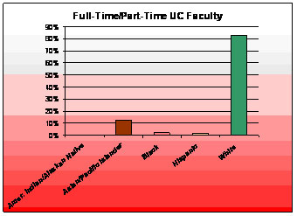
UCCOM Full and Part-time Faculty, 2004
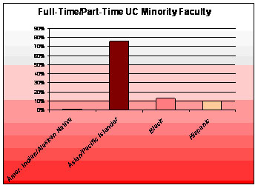
Full and Part-time Underrepresented Minority Faculty
In the last one-two years, the University of Cincinnati College of Medicine has moved closer to closing the "gap" by hiring qualified, skilled and productive new faculty members who comprise our multiethnic faculty. We are dedicated to continue moving this process forward.

Top of Form
We appreciate your feedback. Let us know how we are doing.

Was this information useful to you? Yes No Not Sure |  | Email (optional)
Please tell us how we can better serve you.
Bottom of Form
Copyright © 1994 - 2006 University of Cincinnati
231 Albert Sabin Way, Cincinnati, Ohio 45267 513-558-5575

http://med.uc.edu/Multicultural/MultiContent/FMS.html

